1. **Python Introduction**

## **What is Python?**

**Python is a high-level, interactive, interpreted and object-oriented programming language.**

It was created by Guido van Rossum, and released in 1991.

* **Python is High Level** - Written in a form that is close to our human language. No particular knowledge of the hardware is needed as high level languages create programs that are portable and not tied to a particular computer or microchip.
* **Python is Interactive** – Programmer can interact with the interpreter directly to write your programs using Python prompt.
* **Python is Interpreted** − Python is processed at runtime by the interpreter. You do not need to compile your program before executing it.
* **Python is Object-Oriented** − Python supports all the Object-Oriented techniques such as Class, Object, Methods, Inheritance, Encapsulation and Polymorphism

## **What is Scope of Python?**

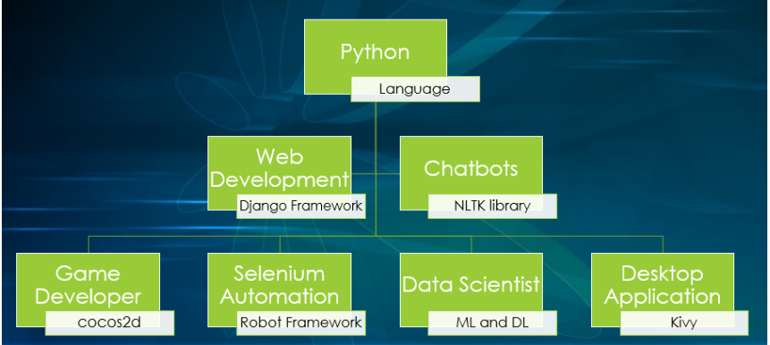

**Python in used to create:**

* Web Applications
* Chatbots
* Video Games
* Automating Application
* Artificial Intelligence algorithms
* Desktop Applications. Etc..,

**How easy to learn Python?**

* Python has a simple syntax similar to the English language.
* No need of programming background.
* Simplest programming language when compared to all other programming languages.

## **Python Syntax compared to other programming languages**

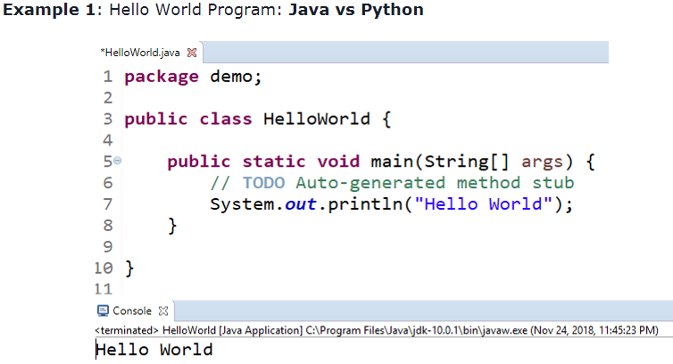

The same program in Python can be coded as below:

# Sample Code

print("Hello World")

Output:

Hello World

**Example 2: Swap the 2 numbers : C vs Python**

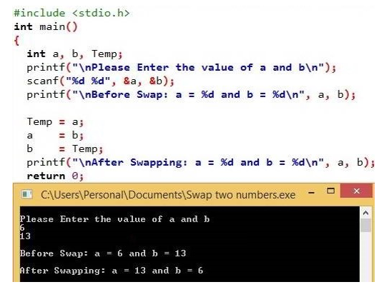

The same program in Python can be coded as below:

# Sample Code

a, b = 6, 13

a, b = b, a

print(a, b)

Output:

13 6

**Example 3: Count total number of times “python” word is displayed: VB Script vs Python**

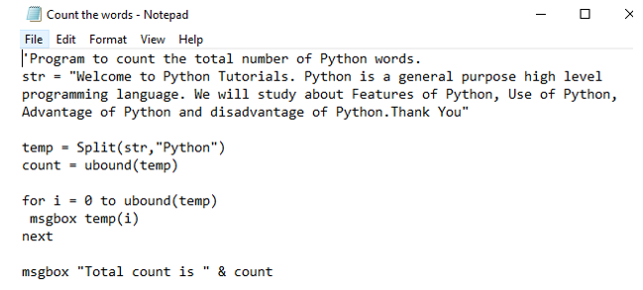

The same program in Python can be coded as below:

# Sample Code

str = "Welcome to Python Tutorials. Python is a general purpose high level  
 programming language.We will study about features of Python, use of Python,  
 advantages of Python and disadvantages of Python.Thank you"

print(str.count("Python")

Output:

6

## **Features of Python**

* Simple and easy to learn
* Free ware and open source
* High Level programming language
* Platform Independent
* Portable
* Dynamically Typed

## ***Limitations of Python***

* It is not suitable for Enterprise application
* It is not used for mobile application

## **Who is using Python?**

* NASA
* Google
* Facebook
* Netflix
* Instagram
* Dropbox
* Quora
* HortonWorks
* Spotify
* Reddit ..etc..

# Python Installation

## Which is best Python IDE ?

IDE means Integrated Development Environment. We have many python IDE tools, each tool is having their own merits and demerits. But my criteria is, both the beginners and advanced user should feel easy to use the Python IDE.

Hence, **Python 3, Anaconda package and Jupyter IDE**will be the best combination to learn python easily.

Anaconda is a package manager, an environment manager, a Python distribution, and a collection of over 1,500+ open source packages. Anaconda is free and easy to install

## Installation Steps

## Step 1 : Checking Python is installed or not.

• Search "Command Prompt" and open it

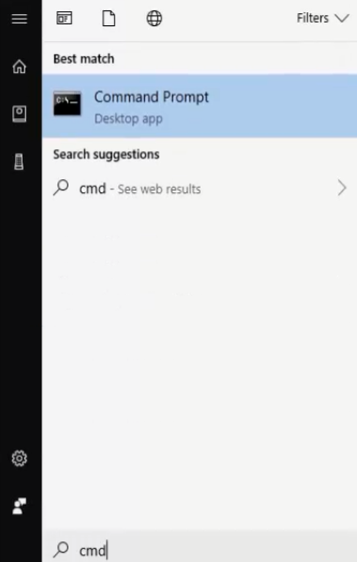

* Type **"python"** in Command Prompt and press Enter key
* If 'python' is not recognized... message is displayed. It means python is not available.

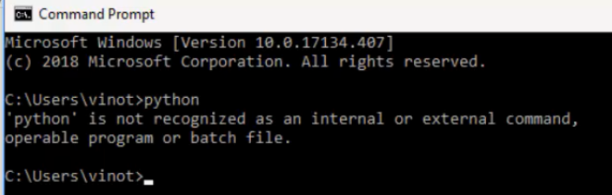

## **Step 2 : Python Installation.**

• Navigate to the mentioned URL: **"https://www.python.org/downloads/"**

• Depends on your operating system(Windows/Mac/Linux). Click on respective link and download the latest python version

**Note:** Initially Python V 2.7 was widely used. Now Python V 3 was released with many updates likes syntax changes , print function , Division operator, xrange, Error Handling etc. We will be using Python 3.

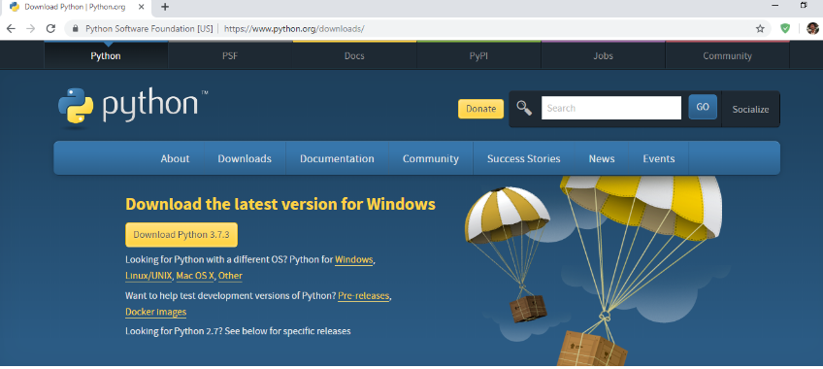

* Move the downloaded file to C Drive(Good practice)
* Right click on the Python file and Click **"Run as administrator"**

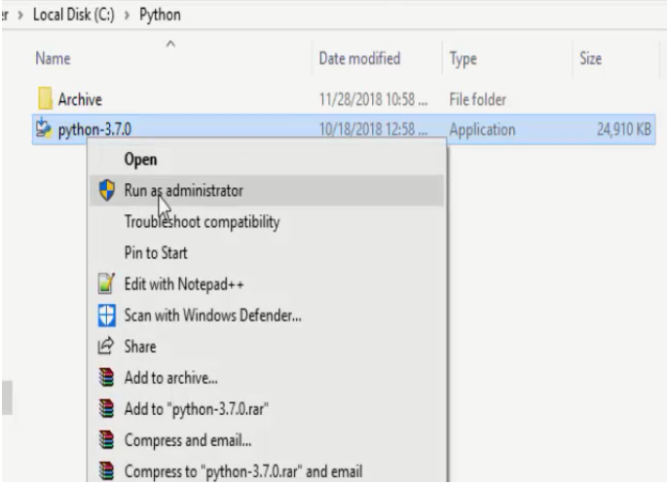

Select **"Add Python 3.7 to PATH"** and click on **"Install Now"**

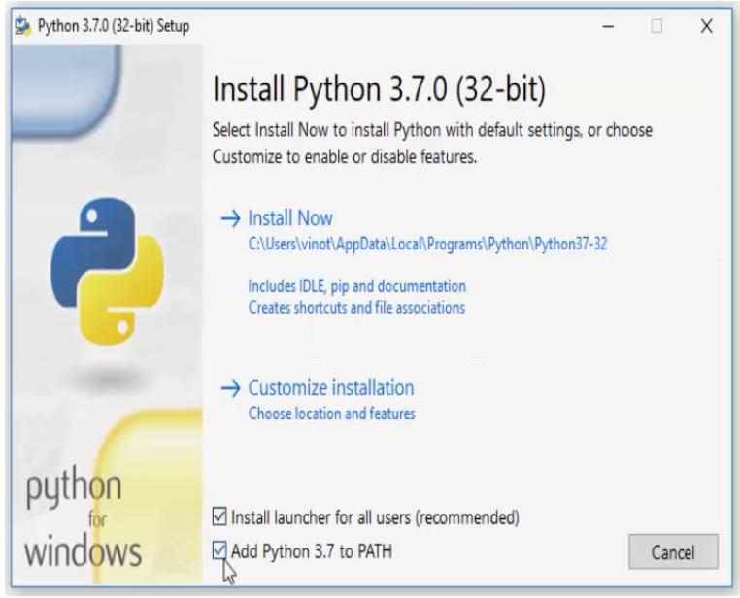

**Installation is started. Wait till it completes**

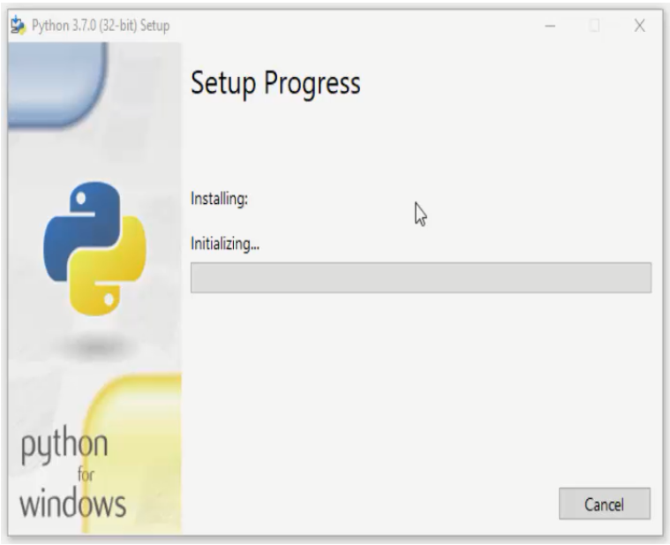

**Python Installation is successful.** Click on "Close"

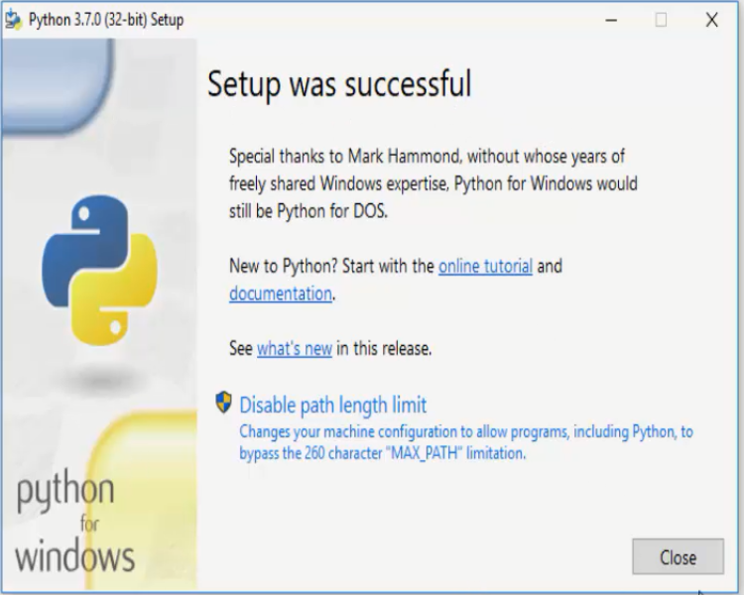

## **Step 3 : Verifying the Python Installation.**

* Type **"python"** in the command Prompt and press Enter key
* Python Installed version message will be displayed as belo

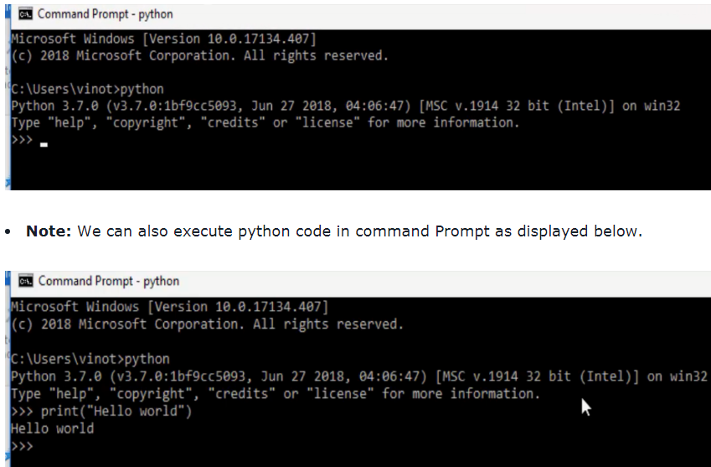

## **Step 4 : Anaconda Installation.**

• Navigate to the mentioned URL: **"https://www.anaconda.com/download/"**

• Scroll Down or Click on "Download"

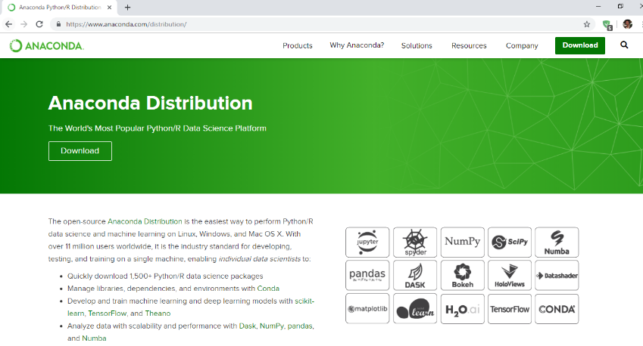

* Depends on your operating system(Windows/Mac/Linux). Click on respective link
* Download the latest **Python 3.7 version** as per your system type(32/64-Bit)

Follow step 5 to find your system type(32/64-Bit).

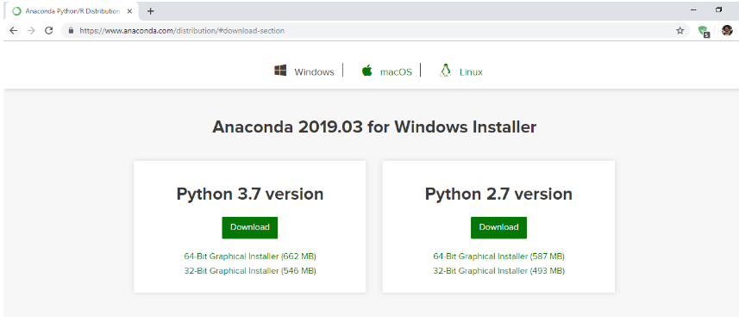

## Step 5 : To find your system type(32/64-bit)

• Search **"This PC" or "My Computer"**

• Right click on it and select **"Properties"**

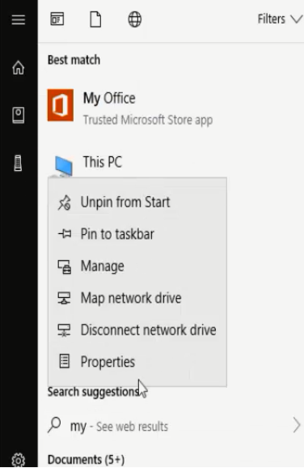

• System type can be found as highlight below. In this example it is 64 bit.

• Now Download the Python 3.7 version for 64 bit

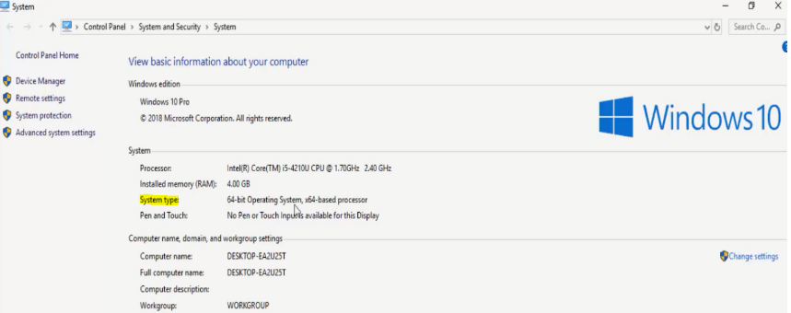

• Move the downloaded file to C Drive(Good practice)

• Right click on the Anaconda file and Click **"Run as administrator"**

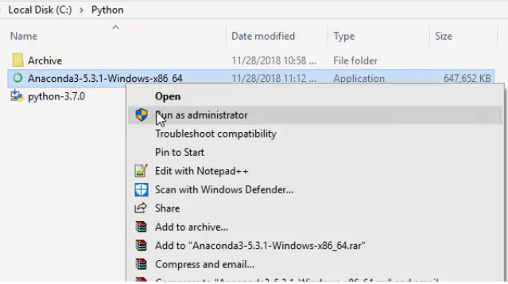

Installation Wizard is opened. Click on **Next"**

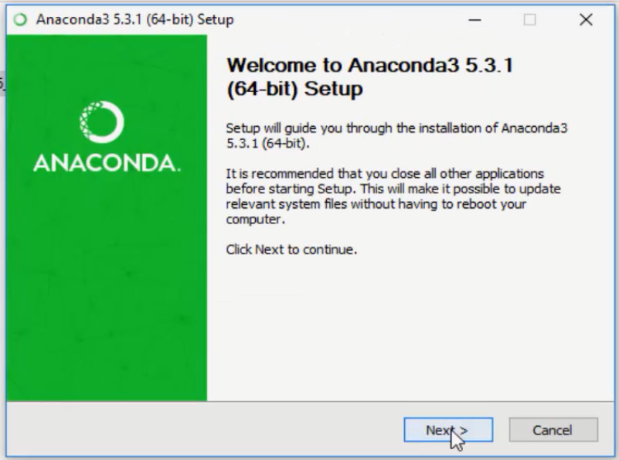

Click on **I Agree"**

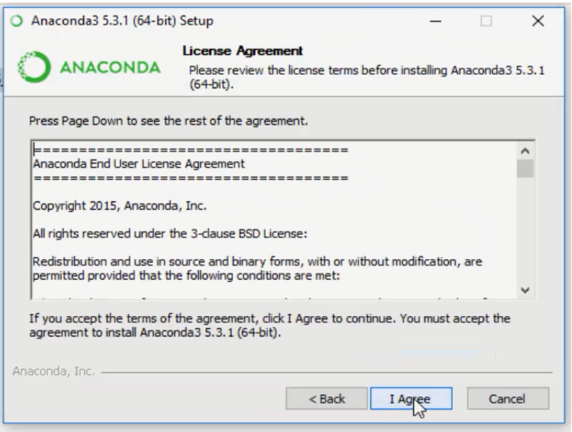

Click on **Next"**

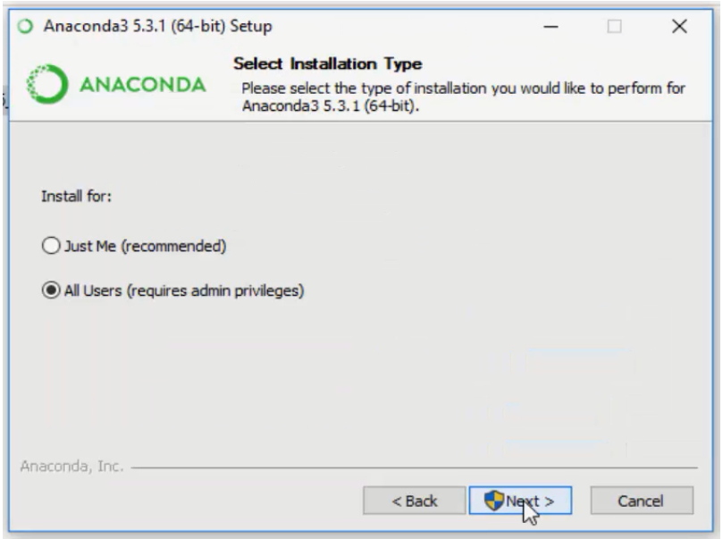

Click on **Next"**

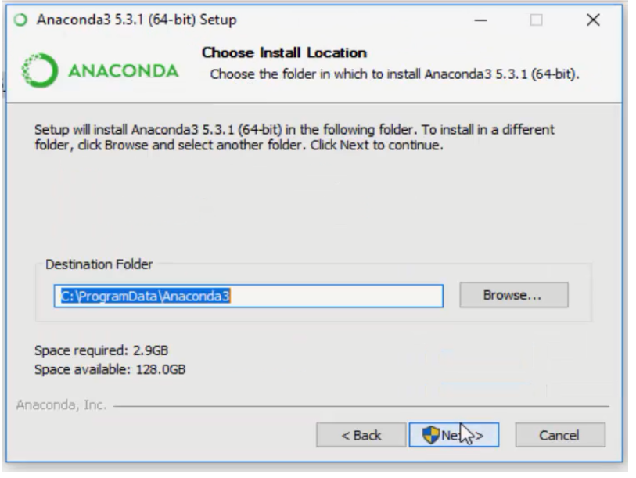

• Select **"Add Anaconda to the System PATH environment Variable"**

• Click on **"Install"**

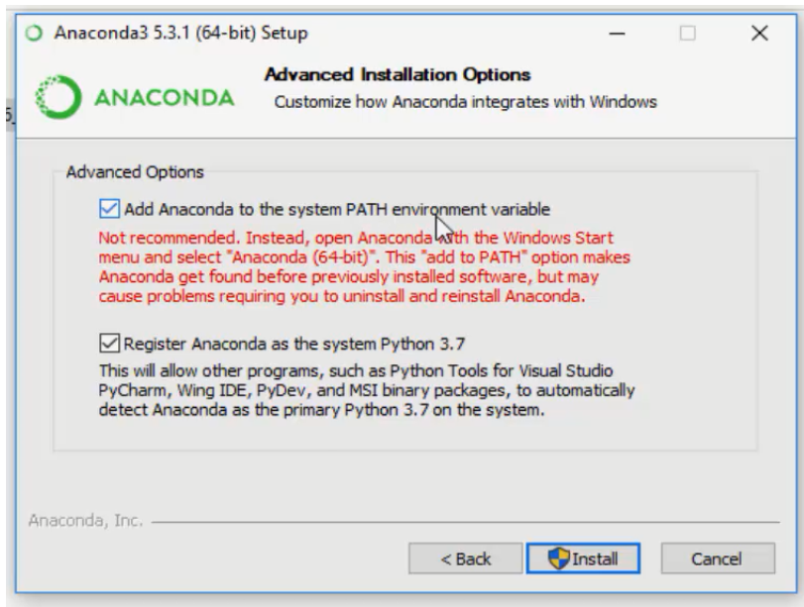

• Installation is started. Wait till it completes

• **Note:** It took 30 minutes for 4GB Ram.

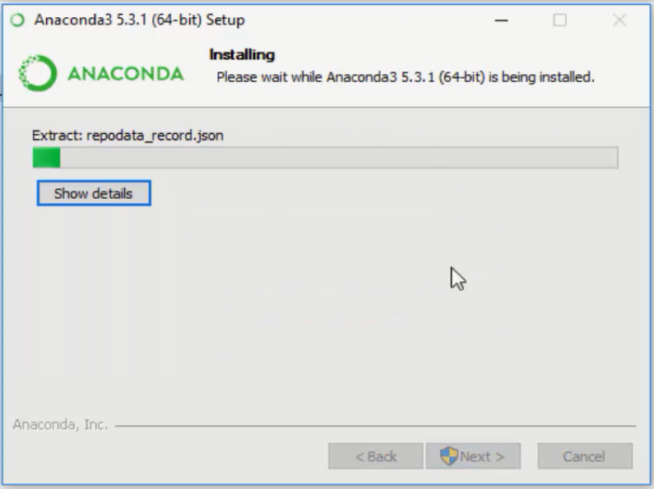

**Anaconda Installation is successful.** Click on "Next"

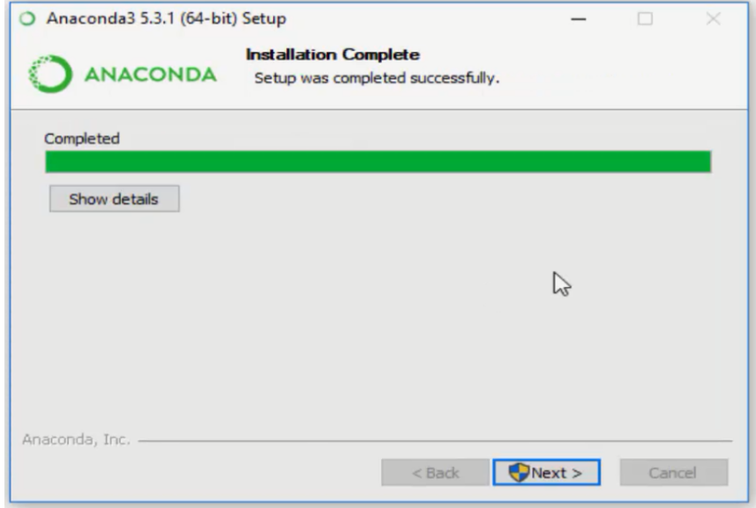

**Click on "Skip"**

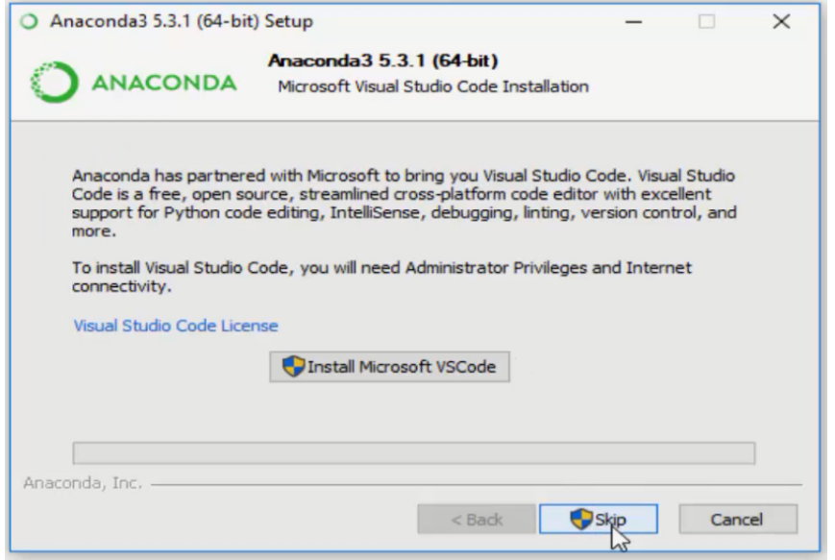

**Click on "Finish"**

